Nama : Maulana Yusuf

NIM : 17090096

Kelas : 5B

Praktikum 2

- Source Code

view-form-matakuliah.php → application/views

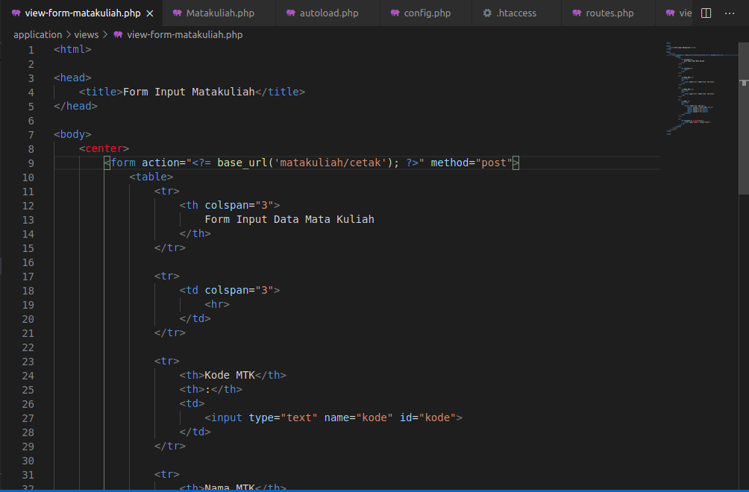

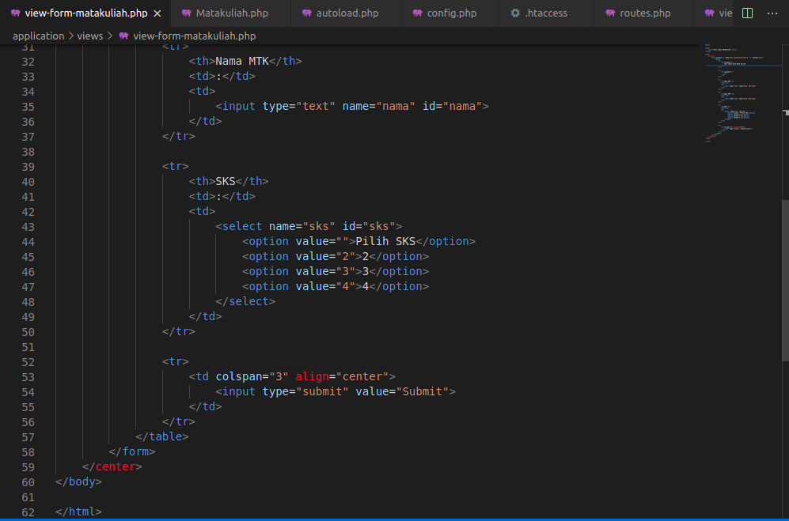

Matakuliah.php → application/controllers

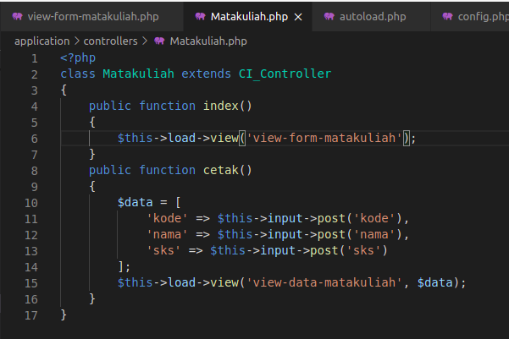

view-data-matakuliah.php → application/views

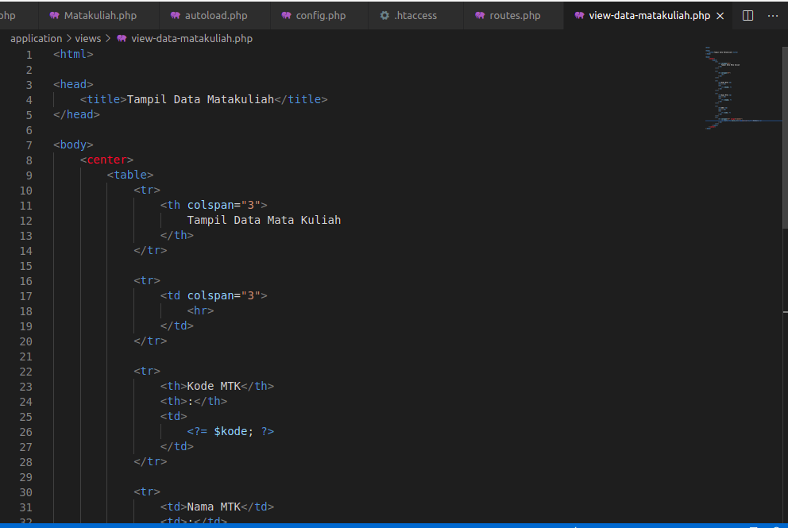

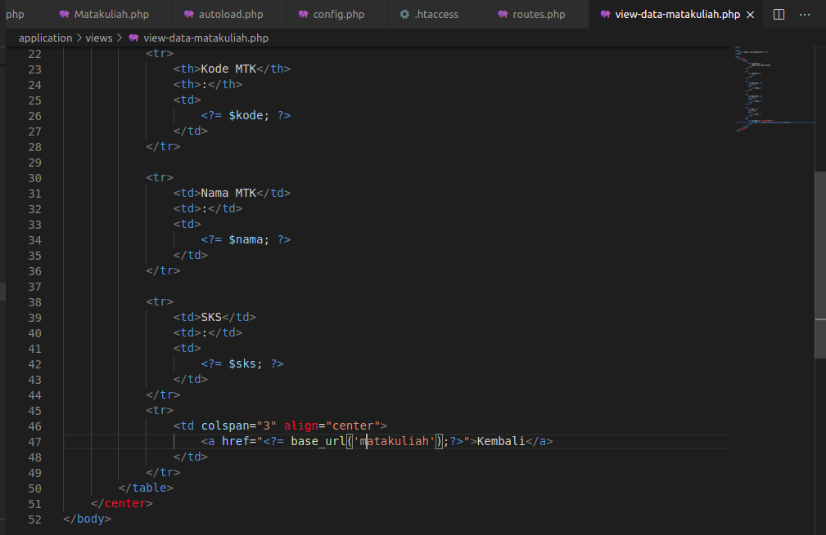

- Hasil URL

http://localhost/pustaka-booking/Matakuliah

- Capture Hasil

